**User Interface Subsystem**

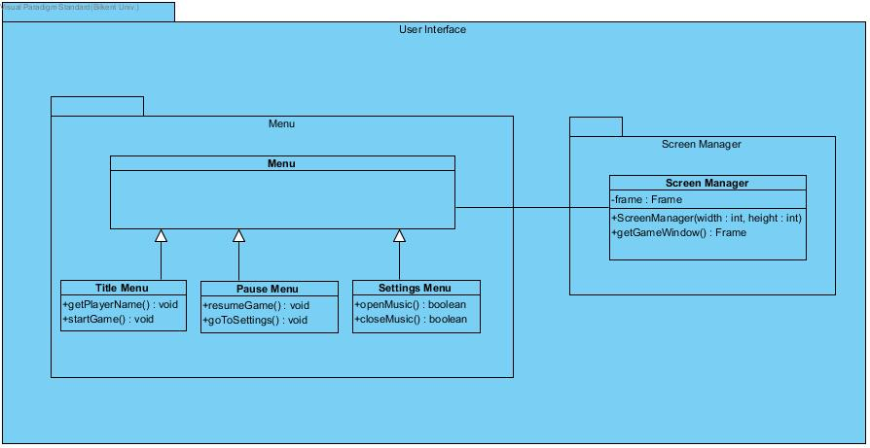

**Menu Class**



This class organizes Title Menu Class, Pause Menu Class, and Settings Menu Class.

**Title Menu Class**



Methods:

public void getPlayerName(): This method gets the player’s name or nick-name. It does not return anything.

public void startGame(): This method starts the game and opens the main game screen. It does not return anything.

**Pause Menu Class**



Methods:

public void resumeGame(): This method stops the game. In other words, it stops the game flow. It does not return anything.

public void goToSettings(): This method displays the setting menu to the user. It does not return anything.

**Setting Menu Class**



Methods:

public boolean openMusic(): This method plays the audio. It returns true if the audio plays, otherwise it returns false if the audio could not be played.

public boolean closeMusic():This method stops the audio. It returns true if the audio stops, otherwise it returns false if the audio could not be stopped.

**Screen Manager Class**

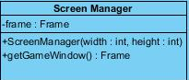

Attributes:

private Frame frame: This is the frame of the screen where the game displays.

Constructors:

public ScreenManager(width : int, height : int): This constructor creates the screen according to the width and height in the parameter.

Methods:

public Frame getGameWindow(): This method displays the game screen. It returns Frame of the game screen.